The Great Exchange – Leader’s Notes
HOOK
1. What was the best vacation you ever had?

2. How many countries of the world have you been to? Do you ever keep any foreign currency after visiting somewhere?

3. What are your vacation plans this summer?

4. If you could be anyone else in the world, who would you choose to be?
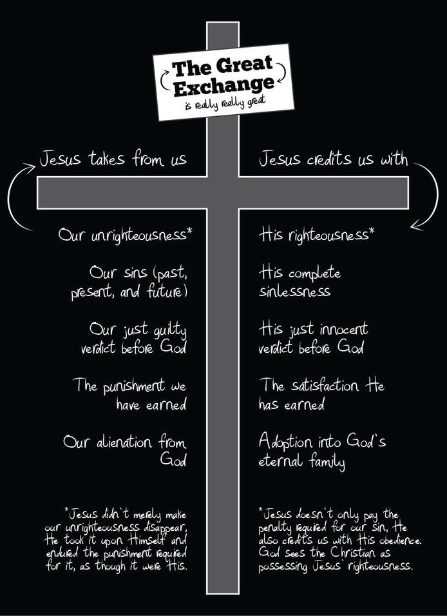
BOOK/LOOK
Read 2 Cor. 5:15-21.
5. What kind of things can you change about yourself, and what kind of things can’t be changed? (You can change your name, your career, your home, your friends, etc. You can’t change your past or who you really are).

6. Who can change us into a new creation (5:17)? How does this happen? (5:18) – “All this is from God”. God is the only one who can really change us, and He does it from the inside out by His mercy and grace, and through the indwelling of the Holy Spirit. “If any one is ‘in Christ’.”)

7. Where do we often hear about truth and reconciliation in Canada? (In relationships with First Nations). What does “reconciliation” mean? (becoming friends with a former enemy). Can we really become friends with God?

8. What’s the Great Exchange? (2 Cor. 5:21). (see the chart). Why is the Great Exchange even better than just “forgiveness”? (Jesus makes us new and we become God’s righteous people).

TOOK
9. How does 2 Cor. 5:15 help us write a personal mission statement? How would you describe your personal mission statement?

10. Is there any human relationship that is broken and needs reconciling? How does the reconciliation offered by God impact those human relationships?

11. What’s makes the Great Exchange difficult to embrace? (We have to give up control of our life).

12. When did you make the Great Exchange? What’s holding you back?

