What in the World am I Here for –
Evangelism: You were made for a mission
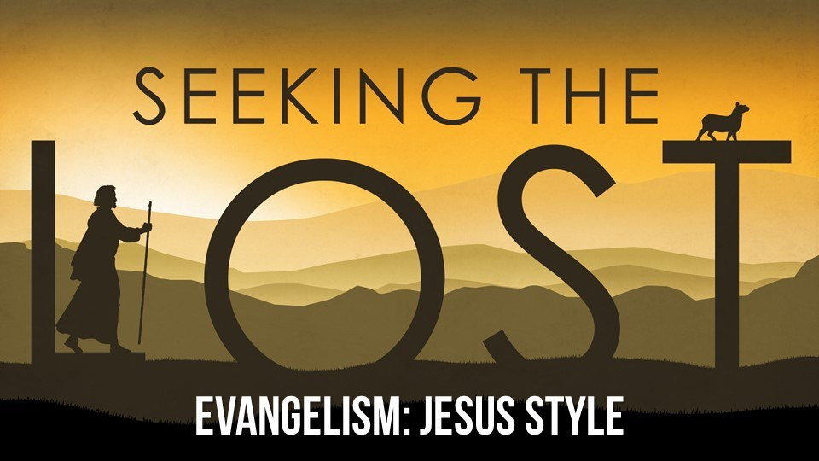
Catching up
1. What’s the most valuable thing you’ve lost and found?

2. Share an insight from your reading in the book that
was especially meaningful to you this week.

3. Who is the person most responsible for introducing you to Jesus Christ?
When, where and how did you become a believer?

Memory Verse: “Work at bringing others to Christ.” 2 Timothy 4:5b (NLT)

Show Rick Warren Video: part 6

“In the same way that you gave me a mission in the world, I give them a mission in the world.” John 17:17 (MSG)

What’s the difference between your ministry and your mission? Your ministry is in the church. Your mission is in the world. Your ministry is to believers. Your mission is to unbelievers.

“The most important thing is that I complete my mission, the work that the Lord Jesus gave me – to tell people the Good News about God’s grace.” Acts 20:24

Two Parts to Your Life Mission

1. God expects me to ______________________________________ people to Jesus.

Aside from your own character, the only thing you’ll take to heaven with you is the people you’ve brought to Jesus Christ. Is anybody going to be in heaven because of you?

Build a bridge to the people in your life by finding something in common with them.

“Whatever a person is like, I try to find common ground with him so that he’ll let me tell him about Christ and let Christ save him.” 1 Corinthians 9:22b (TLB)

2. God expects me to ___________________________________ people for Jesus.

“Go everywhere in the world, and tell the Good News to everyone.” Mark 16:15 (NCV)

“You’ll be my witnesses in Jerusalem, and in all Judea and Samaria, and to the ends of the earth.” Acts 1:8b (NIV)

Jerusalem = your own city
Judea = your region
Samaria = people culturally different from you but who live in the same area
The ends of the earth = everybody else

What is our Motivation for Bringing and Going?

1. We do it because it’s our _____________________________________.

“Much is required from those to whom much is given, for their responsibility is greater.” Luke 12:48b (TLB)

2. We do it because we’ve been given ____________________________________.

“All authority in heaven and on earth has been given to me. Therefore, go and make disciples of all nations.” Matthew 28:18-19a (NIV)

3. We do it because of history’s _______________________________________.

“The Good News about the Kingdom will be preached throughout the whole world, so that all nations will hear it; and then, finally, the end will come.” Matthew 24:14 (NLT)

The Five Global Giants The PEACE Plan
1. P___________________________
2. E___________________________
3. A___________________________
4. C___________________________
5. E___________________________

The PEACE Plan is a grassroots, church-to-church strategy. It’s about all believers in every church doing all of the things Jesus told us to do in the power of the Holy Spirit. It’s about churches partnering with churches to take on the global giants in their communities. It’s about turning an audience into an army, consumers into contributors, and spectators into participators. Only the church has the manpower, the willpower, and the Holy Spirit’s power to do what is otherwise impossible. Jesus has called us, commanded us, and commissioned us to do it. The question is, will you do it? The Great Commission is for every follower of Jesus Christ.

“Send us around the world with the news of your saving power and your eternal plan for all mankind.” Psalm67:2 (TLB)

God doesn’t want anyone to be lost, but he wants all people to change their hearts and lives. 2 Peter 3:9b (NCV)

“Only those who throw away their lives for my sake and for the sake of the Good News will ever know what it means to really live.” Mark 8:35 (TLB)
Discovery Questions

“God expects me to bring people to Jesus.”

Build a bridge to the people in your life by finding something in common with them. Make a list in the space below of five activities you personally enjoy doing. Then write the names of acquaintances who don’t yet know the Lord, whom you could invite to do the activities with you.

Activities People to Invite
(hobbies, sports, work, kids’ clubs, dining out, etc.) (friends, family, coworkers, neighbors)

_________________________________________________________ _______________________________________
_________________________________________________________ _______________________________________
_________________________________________________________ _______________________________________
_________________________________________________________ _______________________________________

Now select one of those activities and make a plan to invite the person/people you listed to do the activity with you. As you get to know them better, look for opportunities to share the love of Jesus with them.

“Be wise in the way you act toward outsiders; make the most of every opportunity. Let your conversation be always full of grace, seasoned with salt, so that you may know how to answer everyone.” Colossians 4:5-6 (NIV)

“Always be prepared to give an answer to everyone who asks you to give the reason for the hope that you have. But do this with gentleness and respect.” 1 Peter 3:15 (NIV)

What principles and ideas can you learn from these verses about sharing Christ with the people you just listed?

Living on Purpose
You don’t have to leave the country to work for PEACE. There are PEACE opportunities right her in your own community. There are poor people who need food, lonely people that need a friend, widows who could use some help around the house, fatherless kids who need mentors, newcomers to Canada who need help with English and are looking for connections in Calgary. There are thousands and thousands of people who need to know the love of Jesus Christ.
Don’t forget the Movie night on Friday, November 29th at 7:00 pm – God’s Not Dead 3: A Light in the Darkness.
Invite others to the Christmas banquet – Friday, December 13th at 6:00 pm.

Prayer
Close your time together by praying for the people you listed above:
Ask God to give you the opportunities and courage to share Christ with others.
Ask God to soften the hearts and prepare them to hear the Good News of Jesus Christ.

